  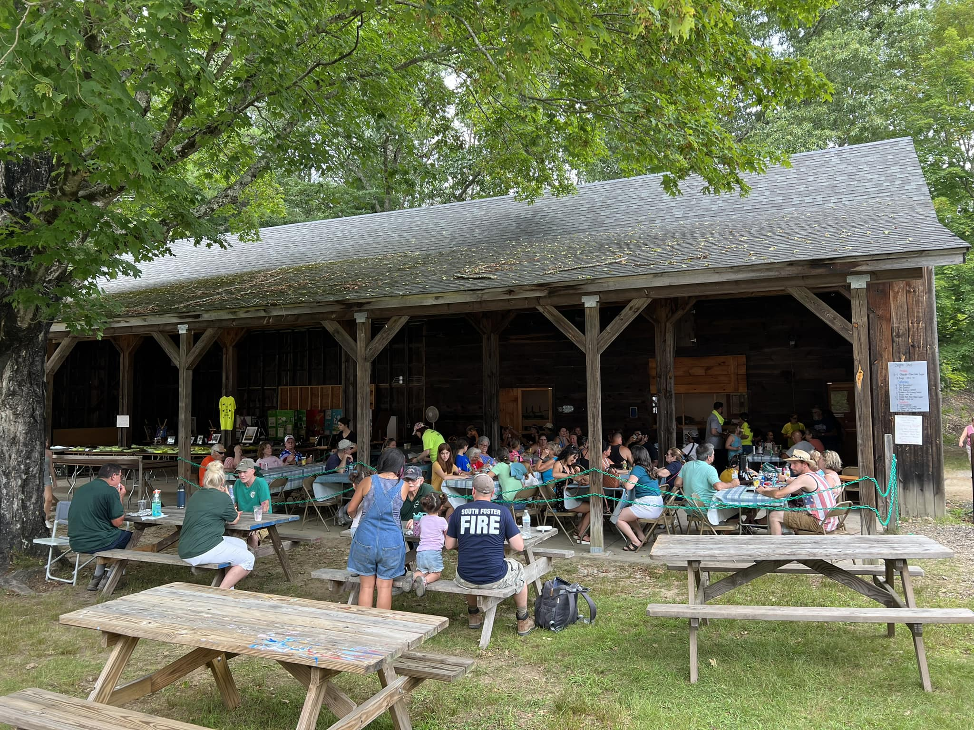
  Foster Old Home Days sole financial support is from donors and fair visitors. The Town of Foster does not provide funding for this event. Completely volunteer led, the Foster Old Home Days Fair Committee reinvests 100% of donations into the fair each year.
  Curious about Costs?
  - Permits, Insurance & Licenses
  - Musicians & Entertainers
  - Demonstrations
  - Contests & Prizes Awarded
  These are just a few of the main areas of cost associated with FOHD. To learn more, reach out to a FOHD Fair Committee member today!
  To:
  Foster Old Home Days
  P.O. Box 33, Foster RI 02857
  Foster Old Home Days
    - Sponsorship Program
  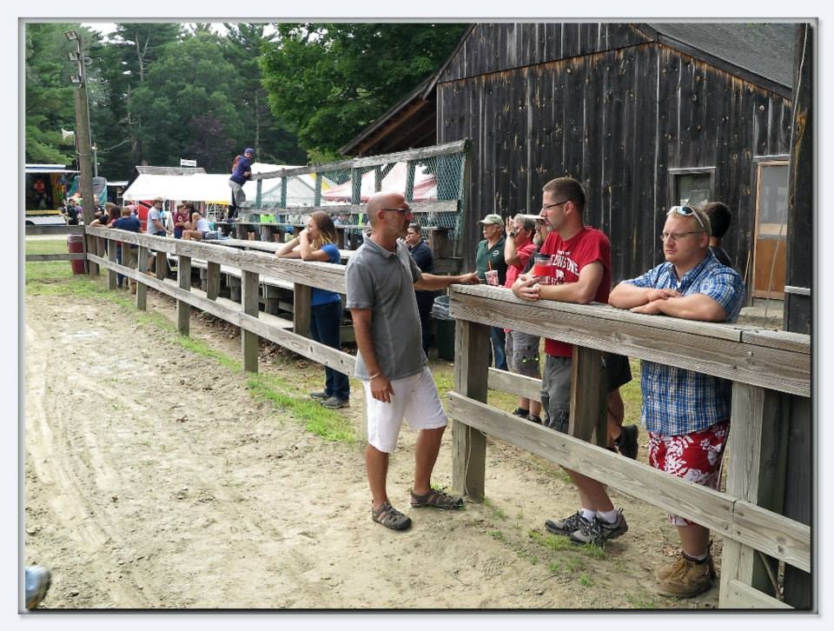

  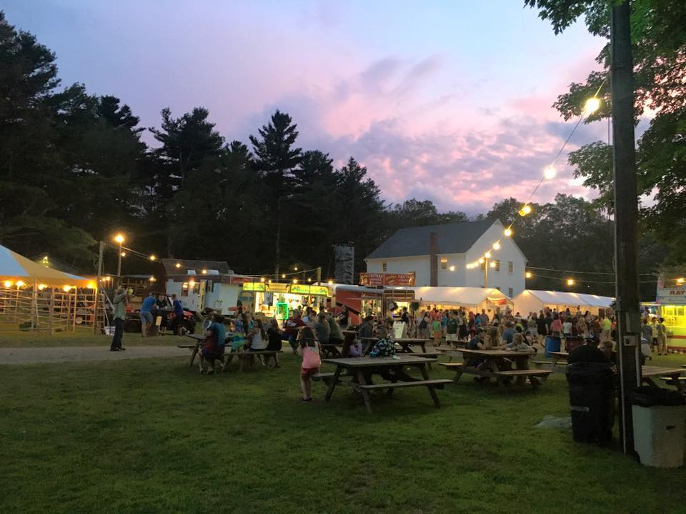
  In the Community
  Foster Old Home Days strengthens the community by bringing residents, local groups, and families together in a shared celebration that builds genuine connection and hometown pride. It boosts the local economy by drawing visitors who support small businesses, vendors, and artisans.
  The event also creates meaningful opportunities for volunteers of all ages to contribute, learn new skills, and feel invested in the town’s traditions. By highlighting local history, talent, and community spirit, FOHD helps preserve Foster’s identity while fostering a sense of belonging. Ultimately, it serves as an anchor event that unites the community and keeps local traditions thriving.
  Supporting FOHD is easy! Cash/check, gift card and item donations (for use as prizes!) are always accepted. Any member of the FOHD Fair Committee can be contacted, or donations can be mailed to the address in our brochure.
  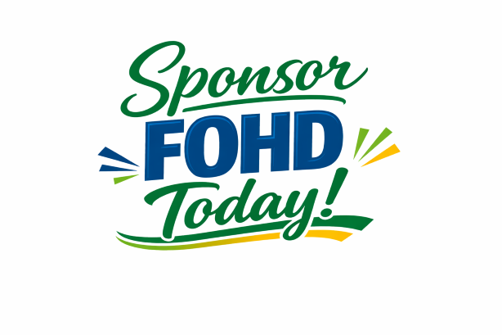
  How You Can Help
  Private Donors
  Contributions are welcome year-round. All private donors will be recognized on various sponsor lists displayed across the fair, as well as on the FOHD website.
  *Anonymous donation requests are always honored.
  Commercial Sponsors
  Business/commercial sponsors- we rely on you the most! Donations of any value are always welcome, and we have a sponsorship program with options to meet every advertising budget-
  Blue Ribbon Sponsor (under $250) Recognition on sponsor lists displayed across the fair, as well as on the FOHD website. Yard Sign displaying your business logo/name on display during the fair.
  Reserve Champion Sponsor ($250- $999) Logo business display on FOHD website, Banner displayed during FOHD fair, social media advertising during fair season (min 6 adverts annually), announcement over loudspeaker during fair (Saturday & Sunday)
  Champion Sponsor ($1000+) Advertising space on FOHD website, social media advertising year-round (min 12 adverts annually), announcement over loudspeaker during fair (Friday, Saturday and Sunday), banner and yard sign displayed during the fair
  “We plan to be there on Sunday morning with our oxen demonstration... we love supporting your event.” —Sandy Eggers
  re
  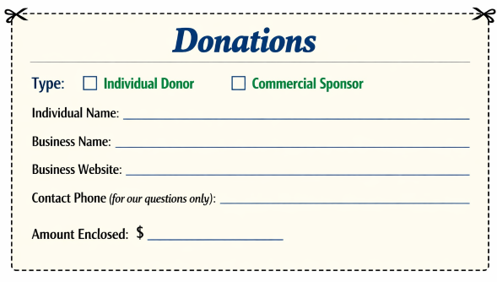
  Contact Us
  Don’t be shy! We love to hear from the community!
  Foster Old Home Days
  [address]
  email- FosterOHD@gmail.com
  Visit us on the Web:
  https://www.fosteroldhomedays.com/
  *Photo credits to Chris Shippee and Davod R. Hughes

